Road Safety Score Predictive Modeling for Smart Bases: 

Fort Carson, Colorado

Final Report

Fall 2022





**Executive Summary** **3**

**Background** **4**

About the Client 4

Previous Capstone Work 4

**Project Objectives** **5**

Introduction 5

Key Stakeholder 5

Deliverables 5

**Value and Business Impact** **7**

**Project Methodology** **8**

Model selection, training and evaluation 8

Dashboard Implementation 8

**Data Analysis** **10**

1. Dataset preparation 10

Crash API 10

Weather API 11

2. EDA 11

3. Data Integration 14

**Outcome** **15**

**Conclusions and Recommendations** **18**

**Lessons Learned** **19**

**Suggestions for Future Work** **20**

**Appendix** **20**

# Executive Summary

In this report the US Ignite Fort Carson Fall 2022 Capstone team will elaborate on the client’s asks and deliverables, our approach to data wrangling and model formation, and final recommendations and future work.

US Ignite is a nonprofit research organization that focuses on optimizing smart cities. For this project, US Ignite has been working with Fort Carson which is based in Colorado Springs. The Fort Carson Traffic and Weather Prediction Platform analyzes traffic and weather data in real time to optimize responses to inclement weather and traffic incidents at Fort Carson in Colorado Springs, Colorado. As a part of this overall project with Fort Carson, US Ignite has partnered with Carnegie Mellon University’s Heinz College to assist with developing predictive crash safety models.

# Background

## About the Client

US Ignite is a nonprofit research organization that focuses on optimizing smart cities. For this project, US Ignite has been working with Fort Carson which is based in Colorado Springs. The Fort Carson Traffic and Weather Prediction Platform analyzes traffic and weather data in real time to optimize responses to inclement weather and traffic incidents at Fort Carson in Colorado Springs, Colorado. With over 30,000 daily commuters to the base and only 7 main gates in which traffic can flow through, congestion and crashes are frequent in the surrounding roadways. Thus, a solution is needed to reduce congestion, crashes, and injuries.

# Project Objectives

## Introduction

**The primary objective of our project is to make the decision making process** of choosing to close the base early, delay the opening of the base, and shutting down the base for the day, **easier** for the Garrison Safety Officer. We accomplish this objective through two main deliverables: a script and dashboard.

## Key Stakeholder

The key stakeholder for our project is the Garrison Safety Officer. The role of the Garrison Safety Officer involves consulting with his/her Traffic Managers, gathering information on the upcoming weather, and ultimately deciding on whether or not to close the base early, delay the opening of the base, close the base for the entire day, or to keep the base open.

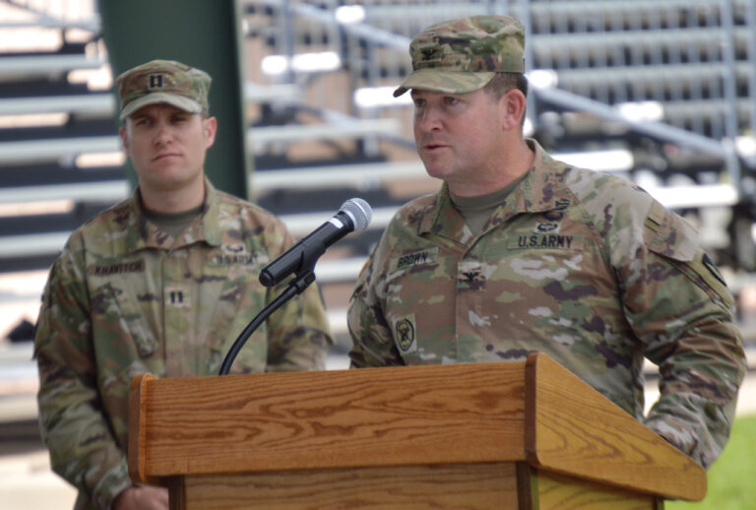

***Col. Sean M. Brown, commander, U.S. Army Garrison Fort Carson***

## Deliverables

The aim of our first deliverable is to train a predictive classification model on a few datasets in order to predict the probability of a crash for a set of roads. These probabilities are defined for each 3rd hour of the day starting at midnight given the upcoming weather forecast, which are then translated into a safety score metric: BRAG (See Figure 1).

*Figure 1: BRAG Condition Rating Score[1]*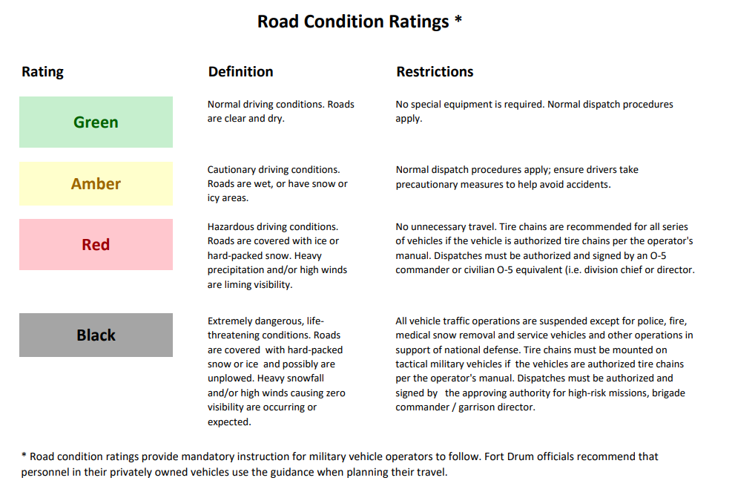

This safety score metric is used by the army for a multitude of reasons, but one use is a road condition safety metric. This acronym stands for Black, Red, Amber, Green, and is an indicator for amount of risk, aka. how safe a road is at a given time with Black having the most risk, and Green having the least risk. The final output for our scores for each road and hour are placed into a spreadsheet for ease of viewing.

Our secondary deliverable of this project is to create a dashboard to serve as a visual aid for the end user. This dashboard connects with the Google Maps API to implement the BRAG score onto the relevant roads. Further explanation of this deliverable is provided in the Project Methodology section.

# Value and Business Impact

The value and business impact of our project stems from speeding up the process of the decision-making process mentioned above. The status quo typically involves base training at roughly 5:30 A.M., and thus the commute times for personnel can start at 4 or 5 A.M. This means that the Garrison Safety Officer would be required to wake up at 2 A.M. to consult with his Traffic Managers on the status of relevant roads in order to post the decision on an announcement board before too many personnel begin their commute. With our project, we enable the Garrison Safety Officer to make this decision the night before or even two nights before.

Thus, our value and business impact is seen through multiple ways: **1) makes the Garrison Safety Officer’s life easier by fast tracking the decision-making process, 2) boosts base productivity by reducing military personnel’s time wasted on the road during inclement weather and 3) reduces crashes and by extension, injury and/or death of both military personnel and civilians.**

# Project Methodology

## Model selection, training and evaluation

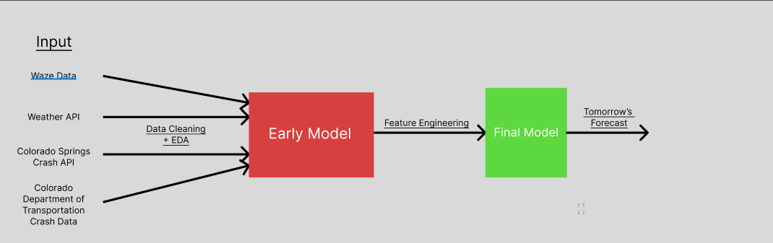

## Dashboard Implementation

For the dashboard, we used Python, JavaScript, HTML as the programming languages. Django servers as the web structure and we implemented Google Map API to display the safety condition in a visual format. The dashboard is also deployed to an AWS EC2 cloud server.

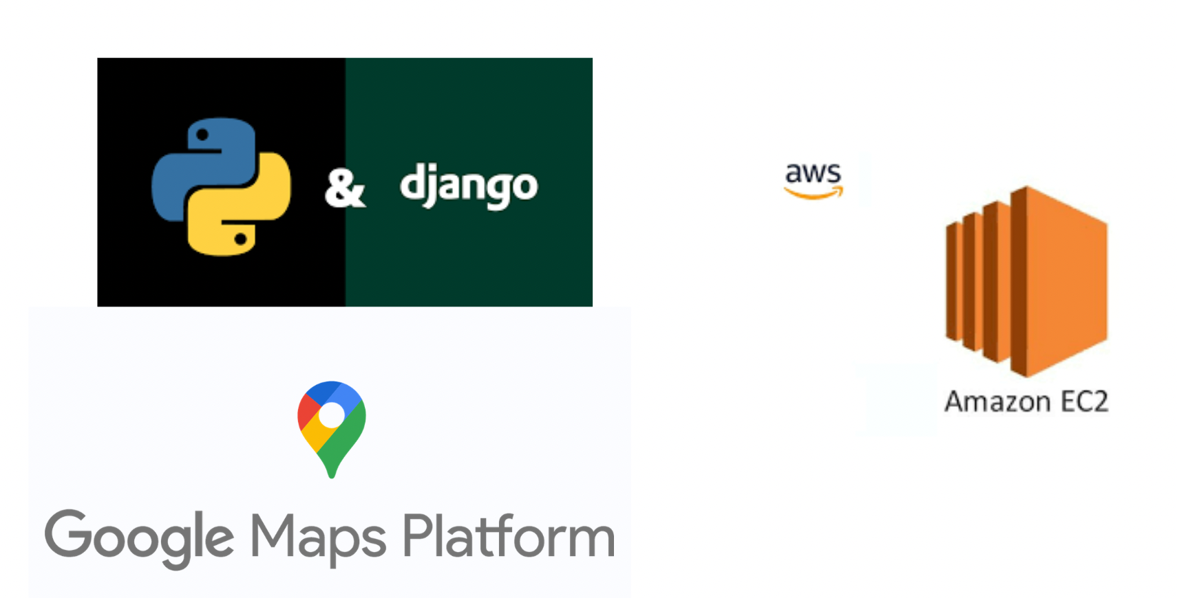

The web platform format provides lots of advantages for current usage and future expansion: accessibility, in which the dashboard can be accessed from any device with an internet connection; scalability, in which it can easily scale up to meet the needs of its users; simplicity, which users can simply log in to the platform through their web browser and start using it right away.

The website is implement with Django framework, which is a high-level Python web framework that encourages rapid development and clean, pragmatic design. It provides feature such as tools for optimizing the application's performance and a robust security system that helps you prevent common web vulnerabilities.

# Data Analysis

## 1. Datasets

### Waze Data

Waze automatically calculates traffic jams by comparing current road conditions with historical road data. When traffic on a segment is below average speed for that time of day/week, we identify it as a slowdown or jam. These are then compared with user GPS signals and user reports. Every datapoint on waze gave information regarding traffic accidents, hazards, construction, potholes, roadkill, stopped vehicles, stopped vehicles, objects on roads, and missing signs. However, upon taking a close look at our project objective, we decided to keep only the relevant columns in our dataset. These are the speed, street, timestamp of occurrence and the jam level on the road during the incident. This data was collected for a period of four years from 2019 to 2022. Only the later months of 2020 were considered so as to prevent the pandemic’s effects.

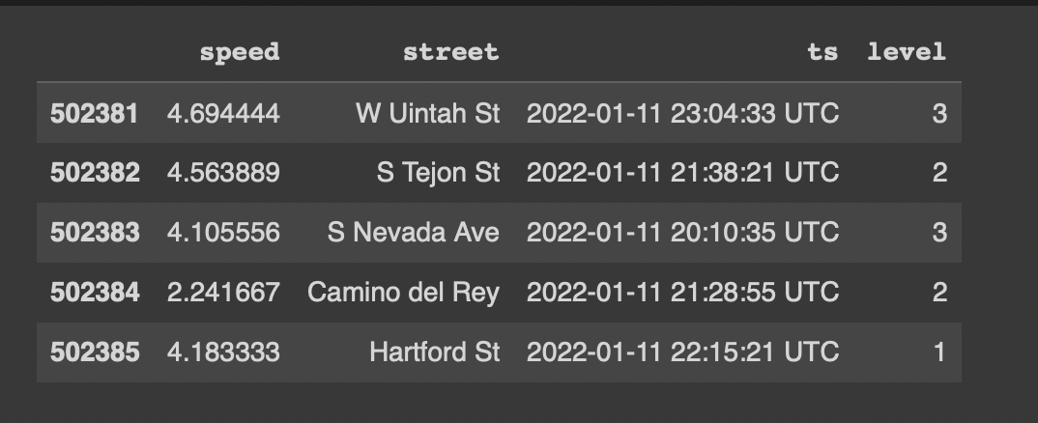

### Crash API

API data comes from the Colorado Department of Transportation (CDOT), which includes detailed statistics on crashes in Colorado in recent years. It includes the time and location of crashes and weather conditions, as well as the damage to transportation. In our project, we focused on the time and place of occurrence.

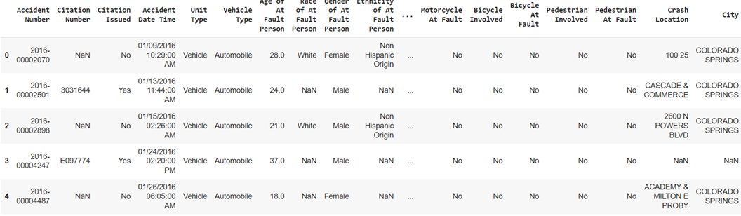

Previously, we chose the csv dataset provided by CDOT, but since it covered too few years, we eventually turned to API data. For the crash api dataset, we first unified the format of the timestamp by rounding it to the nearest hour. Second, because there are many location columns containing roads that are not unique, we transformed them into multiple columns containing only one road per column by string manipulation. If one of these accident locations has a road in our target road dataset, we will keep this row. For the corresponding roads, we also unify their expressions by means of regular expressions.

### Weather API

The weather data comes from the open weather api, which includes both numerical data such as temperature and pressure, and categorical data such as weather and weather descriptions. For numerical data, we normalize the data in the model, and for categorical data, we use one hot encoding to make it fit the model better. Similarly, for the timestamps, we merge and round them to make them consistent with the time format of other datasets.

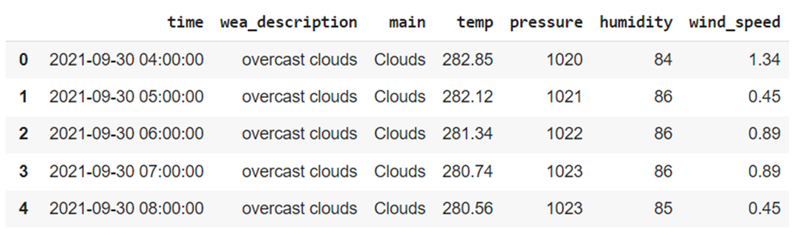

## 2. Exploratory Data Analysis

Upon taking a closer look at Waze data, we find many interesting patterns and results. Firstly, as seen in the visualization below, the streets I-25 and S Nevada Ave contribute to over 40 percent of the data points. This is interesting since these both streets are the largest in terms of commute to the Ft Carson Base. Our model can do a good job since we have interpretable data.

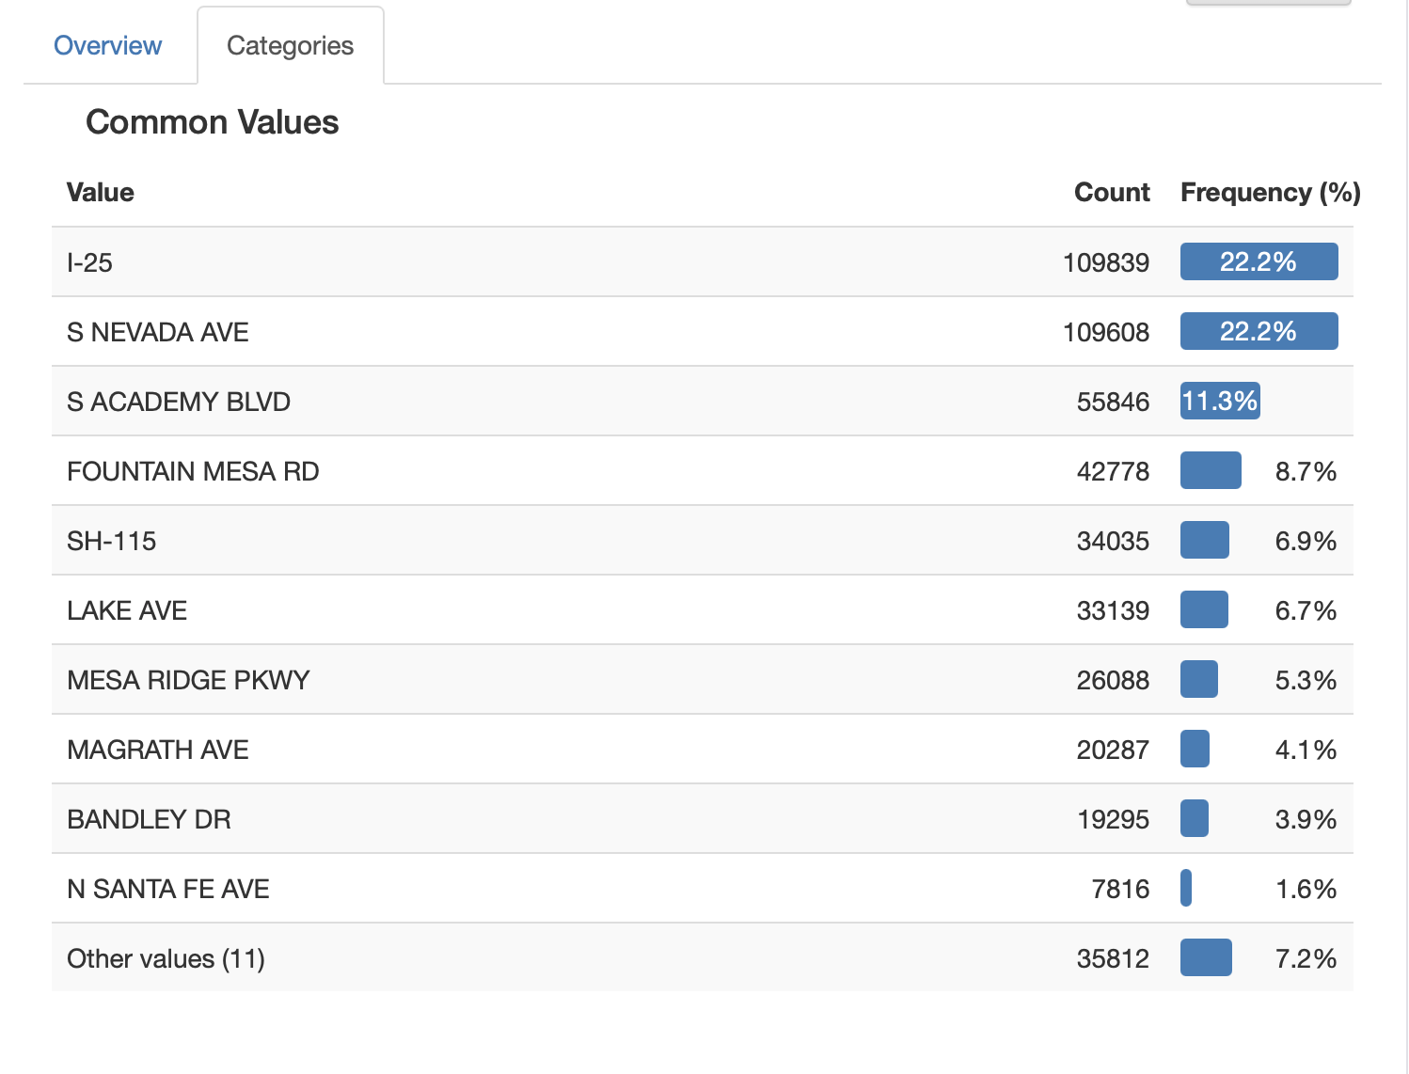

Moreover, looking at the jam level distribution in the data, as seen below, we can see that most roads have a jam level of 3 in and around Fort Carson. Moreover, it appears that there is a lot of movement in general on these roads in particular.

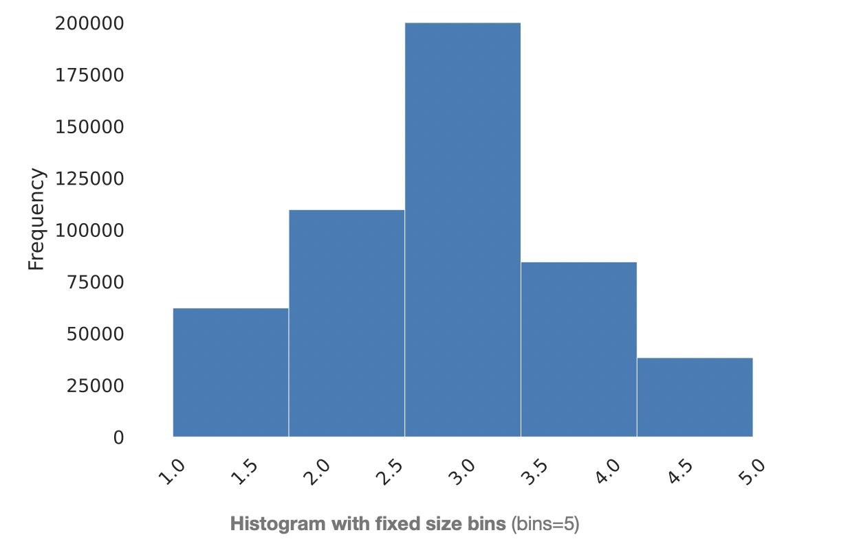

However, one important problem that we noticed when we performed EDA on Waze data was that a lot of speed entries in the data were a glaring zero. We assume that speed is one of the most important factors to predict the occurrence of a crash on these roads. So, there needs to be a good representation of this particular feature. In order to resolve this problem, we took the median of historical data grouped into hourly intervals for every street and inculcated these values in place of the null values.

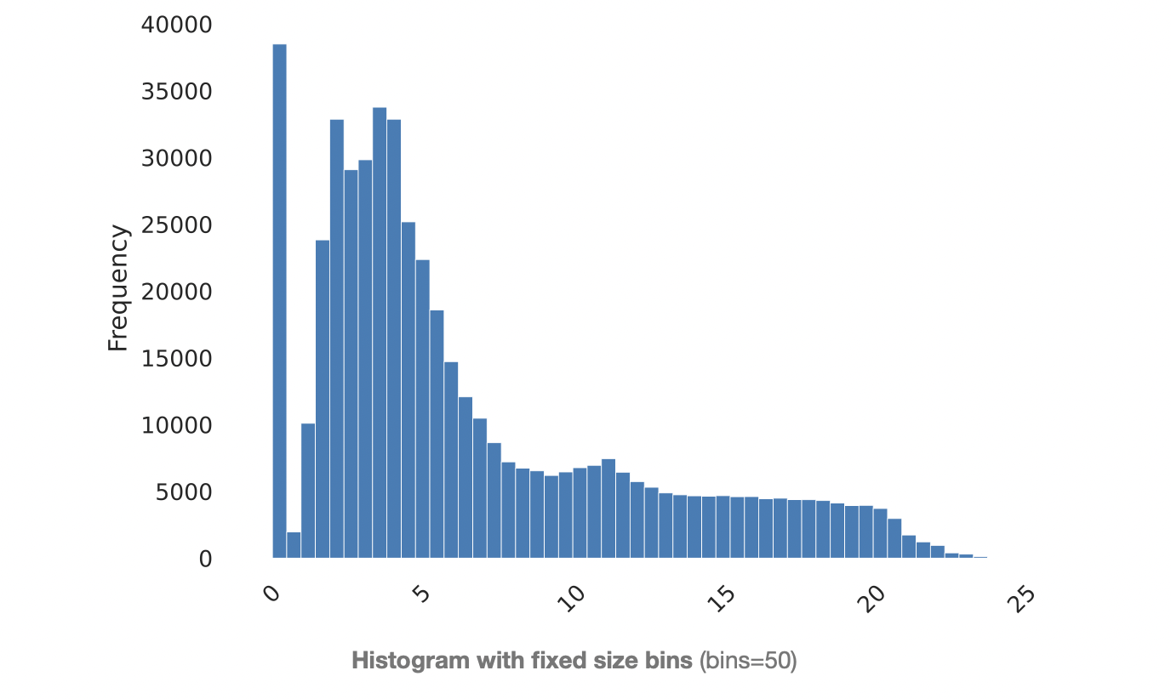

If we categorize the number of crashes in Colorado by weather, we find that, intuitively, crashes occurring in dry weather account for the majority of crashes. It should be noted, however, that although icy, snowy, and wet are not a large part of the total number of weather, they are still accompanied by a significant number of crashes, which is an important reason for including weather in our model. Overall, the weather pattern in Colorado was more stable over the three years from 2017-2019, which provided the basis for introducing weather as an important indicator.

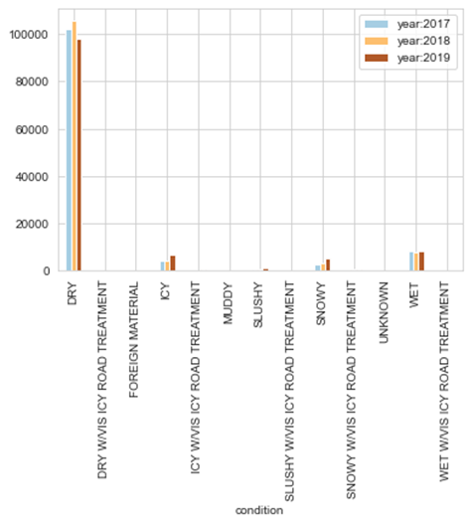

If we turn our attention to the relationship between time of day and the occurrence of crashes, we find that crashes occur more intensively at certain times of the day. For example, more crashes occur between 7-8AM in the morning and between 4-6PM in the afternoon, during the morning and evening rush hours. Therefore, we rounded all timestamps to the nearest hour to reflect the time characteristics of the accident and added it to the model.

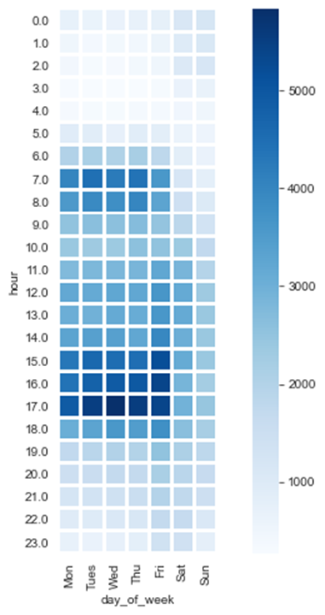

There are also correlations between columns of the data set, for example between whether it is a highway and the driving speed. Since the dimensions in the dataset are inscribed on the same topic, such correlations are inevitable. Therefore, we will weaken the impact of this correlation on the model itself by manually selecting columns during the modeling process.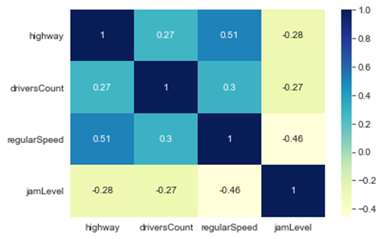

## 

## 3. Data Integration

After processing all the datasets, we will output the final dataset. Overall, the dataset is divided into two parts, one is the regular basis data portrayal, which includes traffic data provided by waze and weather data provided by openweather api, this part of the dataset includes the conditions at all time points, whether there is a crash or not. The other part of the dataset from the Colorado Department of Transportation includes only crash-related data.

For weather and waze data, we merge the two together by timestamp. And for crash data, we add the road name information in addition to the timestamp. And we merge these three datasets together by outer join. Finally, we created the crash label column, if a crash occurred, then it is recorded as 1, and vice versa as 0. This will be our final modeling dataset.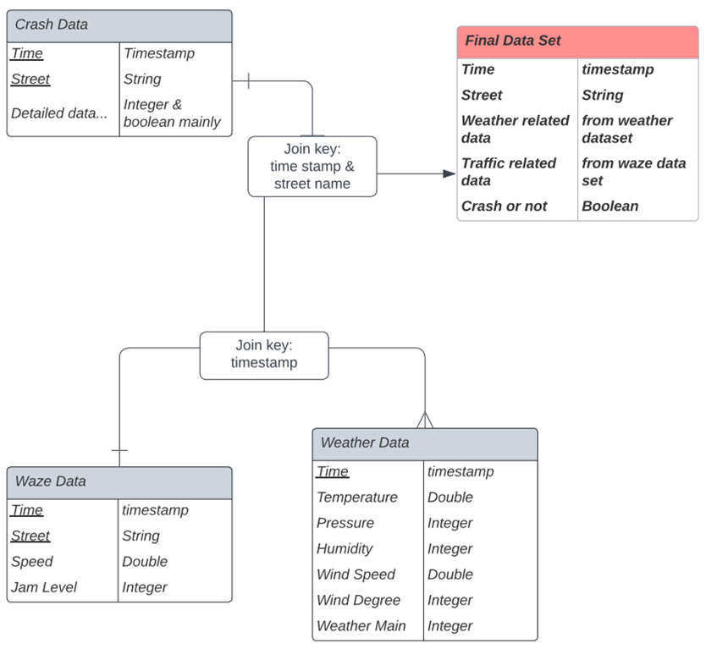

# 

# Outcome

As the project outcome, we developed a web-based platform that displays the brag score predictions for all the roads we selected associated with the Fort Carson Command for up to 72 hours.

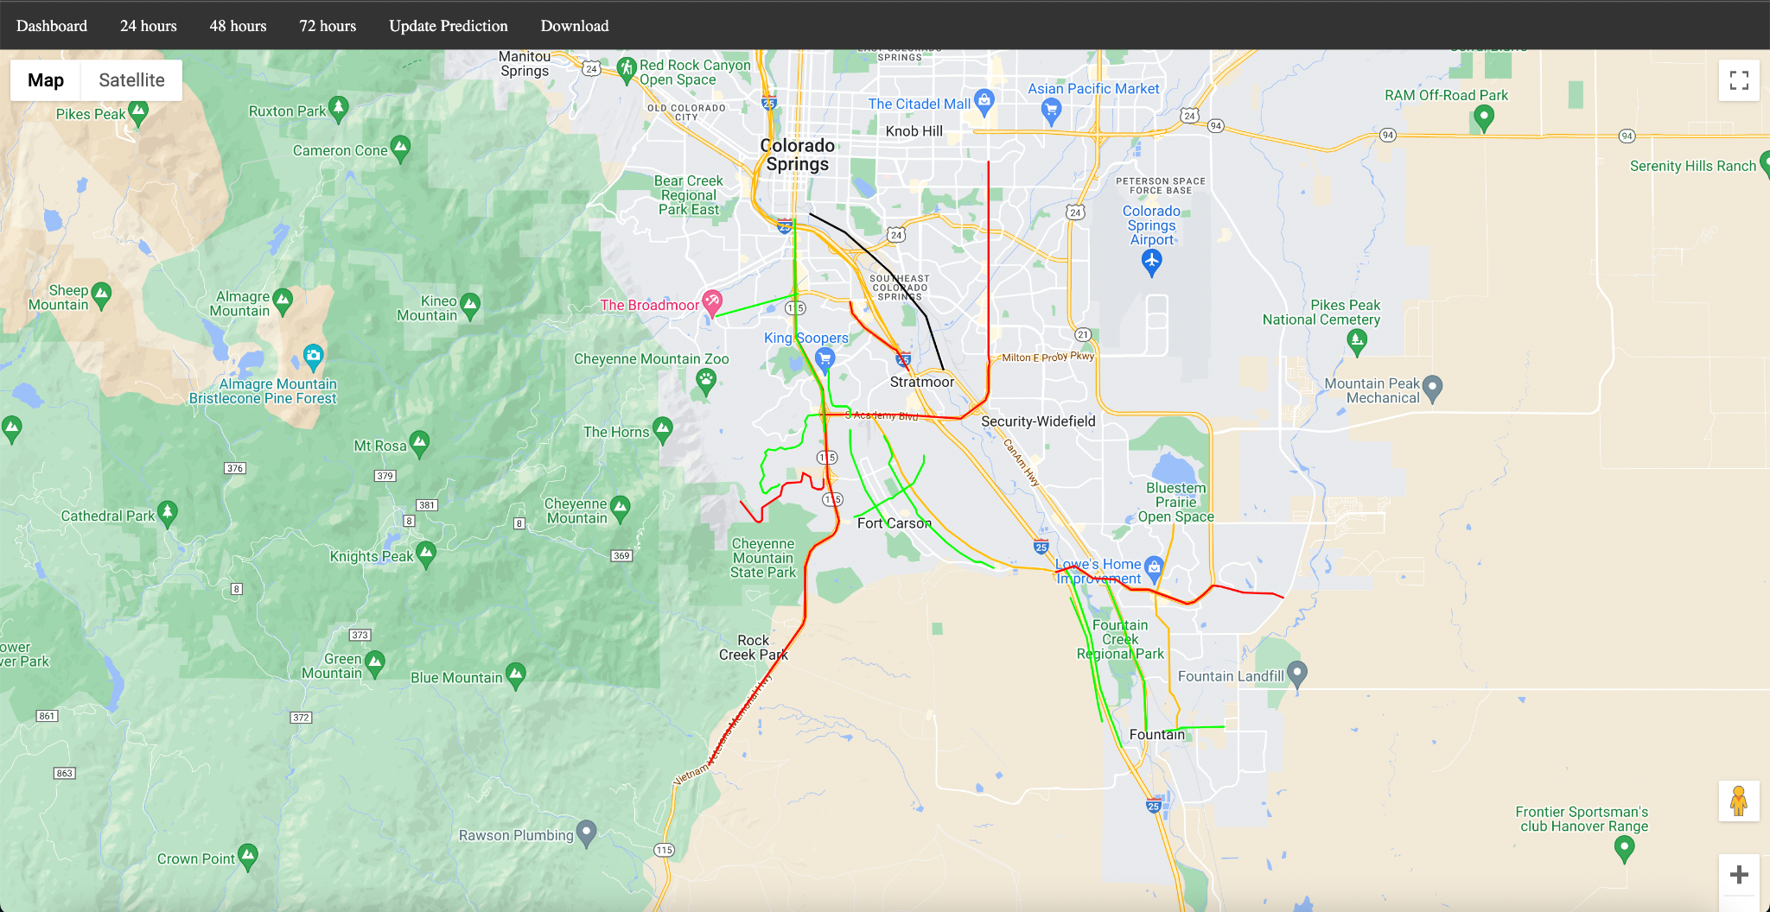

The dashboard consists of a navigation bar that provides users with different selections and a map that visualizes the safety score predictions. For the map section, we integrated Google Map API and used polylines to mark out all the roads we selected that are essential for the commute safety of the personnel at the fort Carson command.

The map provides both 2D and satellite maps for users to view based on their needs. All the roads that we selected are marked in black, red, amber, and green based on our safety metrics and our model predictions.

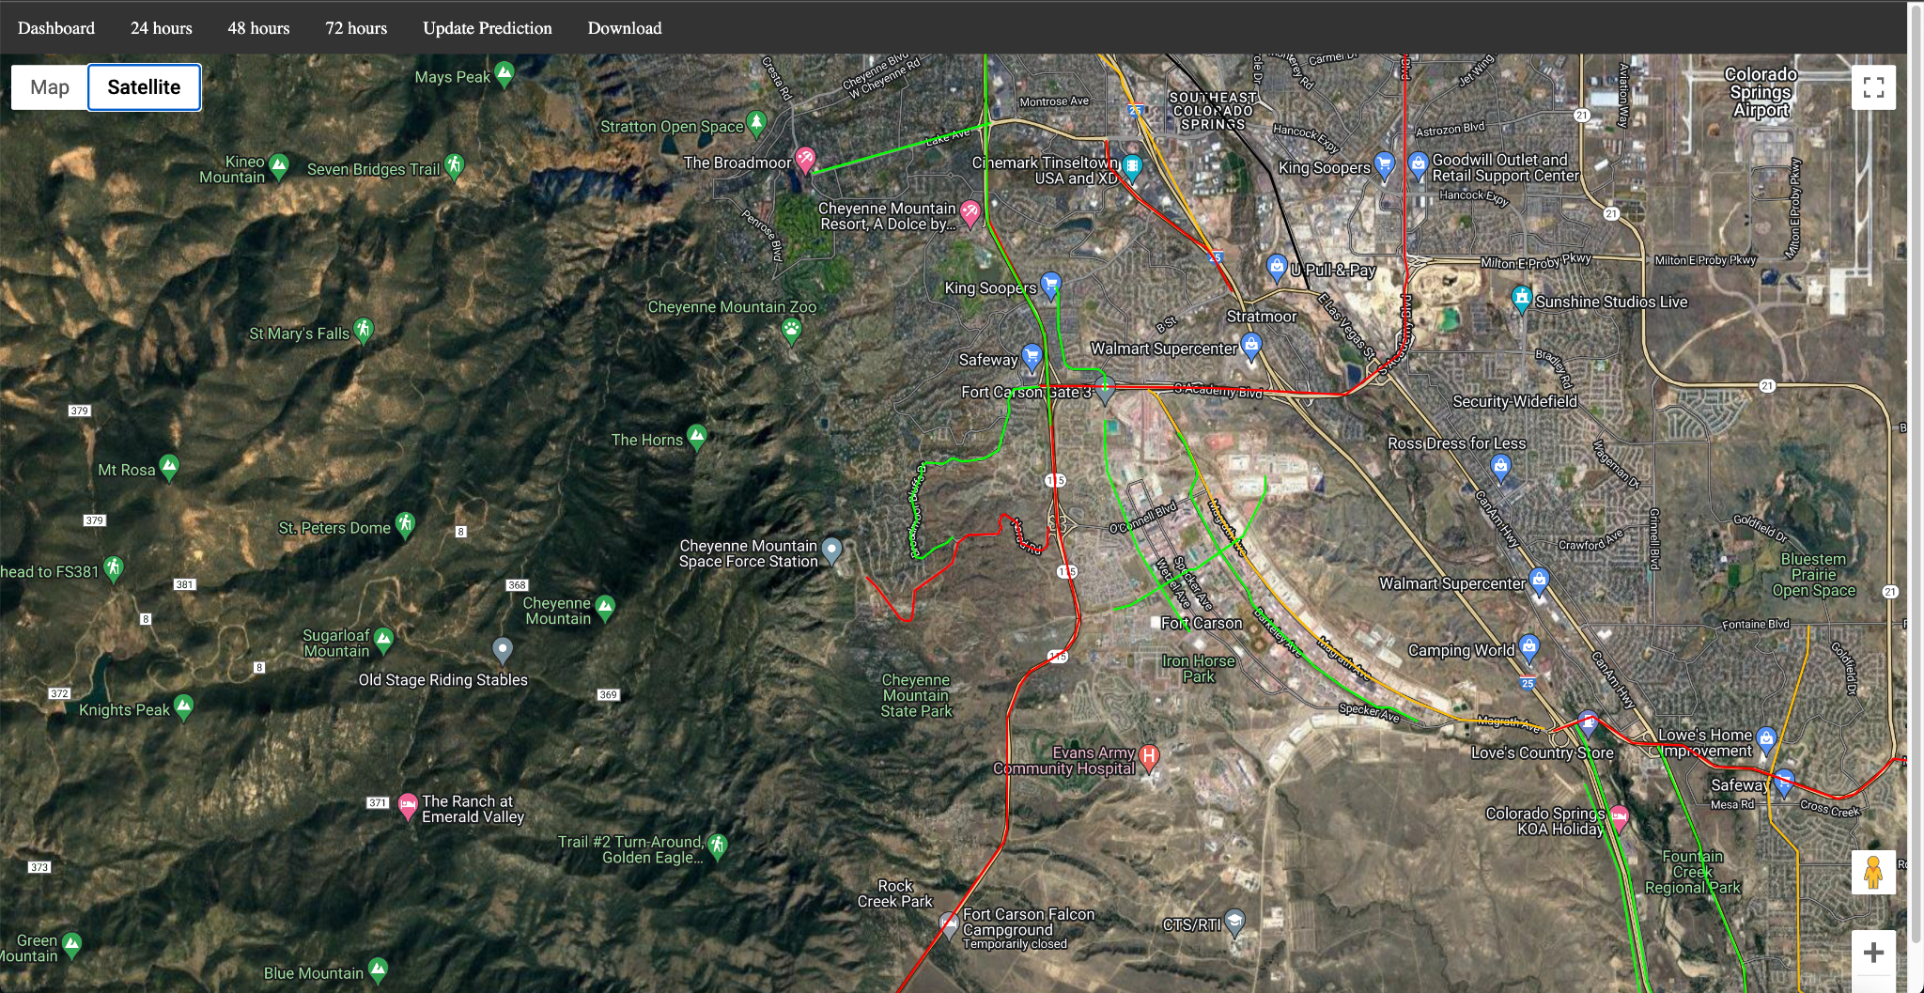

For example, S Academy Blvd is marked red, which indicates a relatively low level of security based on the prediction. And users get to zoom in and zoom out and even use Google Street View just like using regular Google Maps.

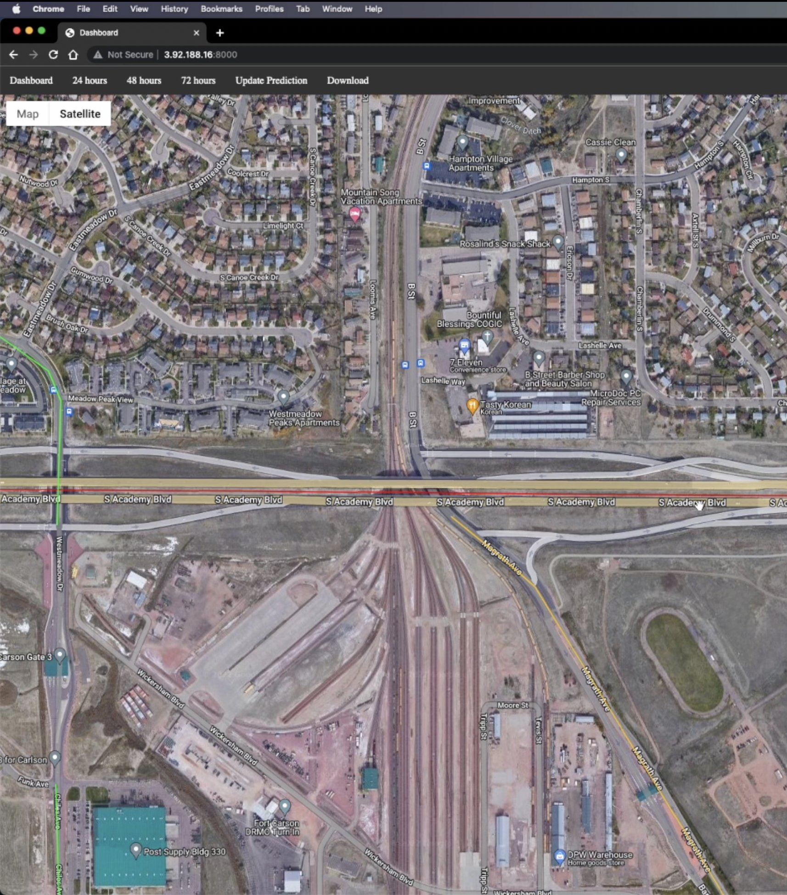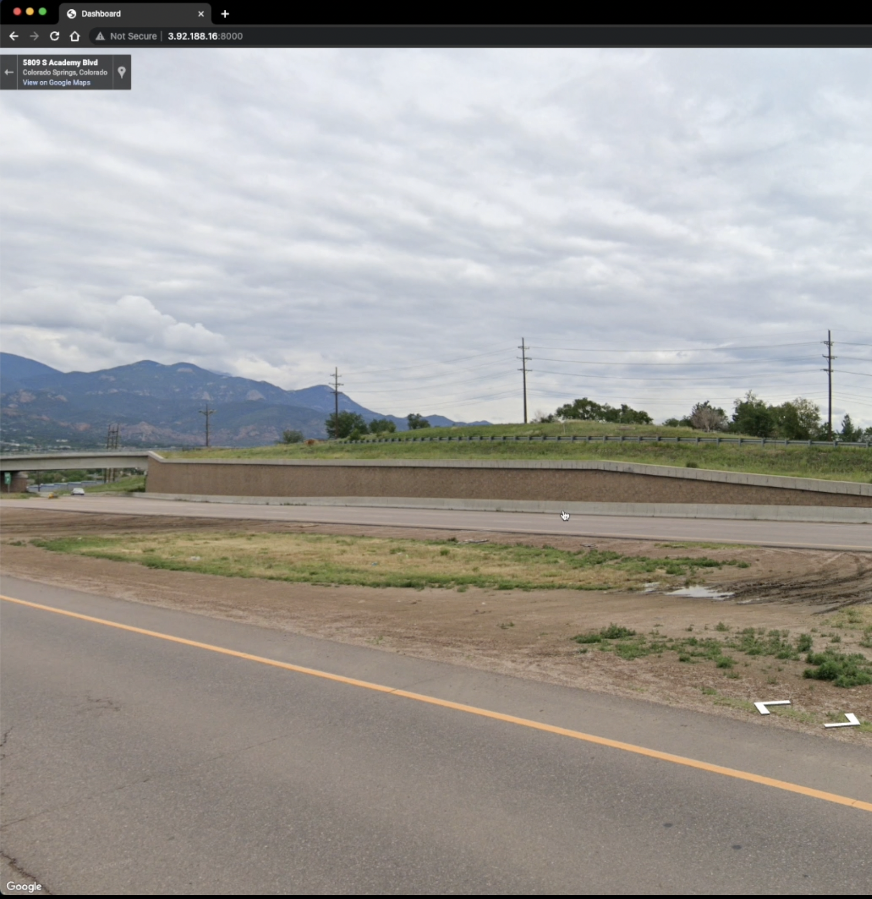

They can click on the update prediction button to update the prediction based on the current timestamp and the new data retrieved from the Open Weather API.

If the user wants to see a detailed brag prediction, they can also click download. After clicking the button, a CSV file that contains all the predictions for the next 24, 48, and 72 hours of safety prediction will be downloaded. The prediction is recorded in a 3-hour interval, which enables the user to view an in-depth and accurate brag prediction.

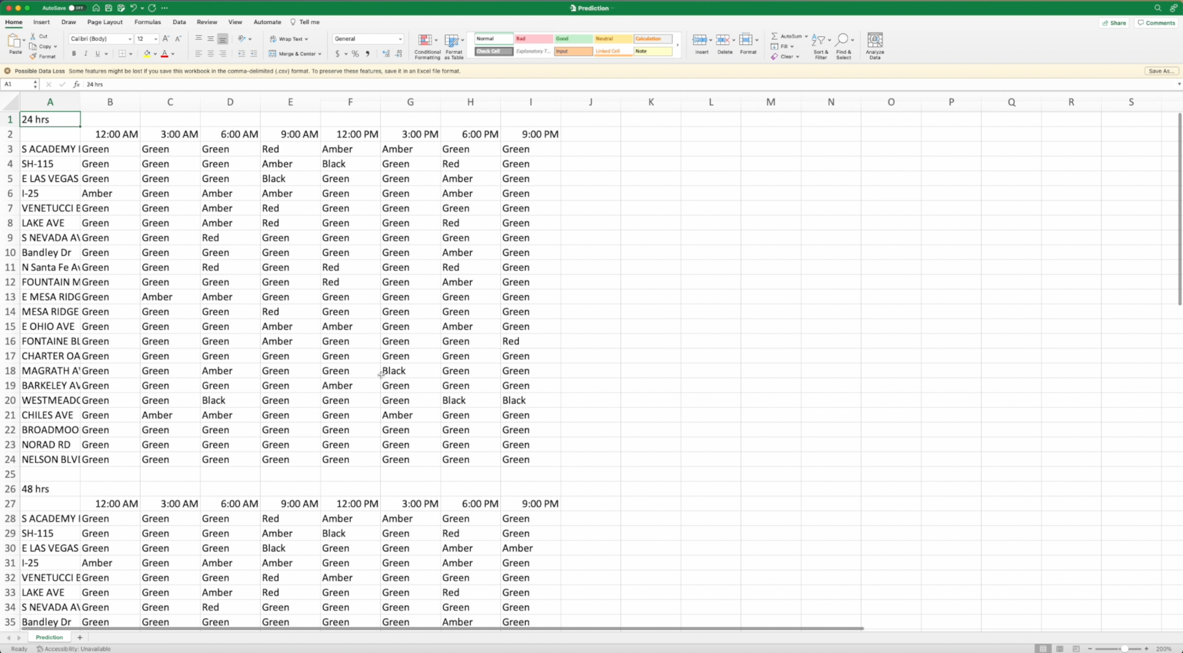

# Conclusions and Recommendations

# 

# Lessons Learned

1. Technical -

* Feature selection is a critical step in our project, as it involves choosing the most relevant and informative input features to use in training a model. There are many features in Waze, Open Weather API, Colorado Spring crash data, and Colorado Department of Transportation crash data. The selection of features can greatly impact the performance of the model, as using too many irrelevant or redundant features can lead to overfitting, while using too few relevant features can lead to underfitting. Feature selection can help to improve the interpretability of the model by reducing the number of input variables that need to be considered, and it can also help to reduce the computational complexity of the model and improve its training and prediction speed.
* Model selection and optimization are critical: There are many different types of machine learning models that can be used for safety score predictions, and it is important to select the most appropriate model for the task at hand. It is also important to optimize the model's hyperparameters to ensure that it is performing as well as possible.

1. Managerial -

* From a managerial perspective, this project required a lot of to-and-fro discussion every step of the way with not just all team members, but also the client representative and the faculty advisor. This meant constantly trying to figure out what approaches to take and when to meet. A big part of this was also making sure everybody was on the same page. This was the biggest challenge that we faced as a team. The lesson learned from this experience was effective project planning and making sure we had a buffer of at least three days before any deadline or submission.
* To ensure everybody was on track while carrying out the assigned tasks, we used numerous project planning tools like Trello and Slack that made it easier for everyone to understand and visualize not just the progress of every week, but also see the contributions made by other team members. We figured this out early on in the project, and doing so saved everyone a lot of confusion and time.
* For any team to function properly, effective channels of communication are extremely important. Our team constantly pushed each other to perform and give their best to the project. This took place by creating a safe environment open to different views and discussions.

# Suggestions for Future Work

# Appendix

1. https://home.army.mil/drum/application/files/3315/3451/6680/Road_Condition_Ratings_Chart.pdf